**Exercise2**

** Click on following link to get all the datasets required for this exercises [https://github.com/PurpleGrad/2203/blob/main/dataset%20for%20Exercise%202.zip](%20https:/github.com/PurpleGrad/2203/blob/main/dataset%20for%20Exercise%202.zip)

**1)** For this Exercise use the **Populations** dataset from the given link

Create a new Power BI Desktop file, and load the Excel workbook in the above folder into it.  Use this to create the following donut chart:

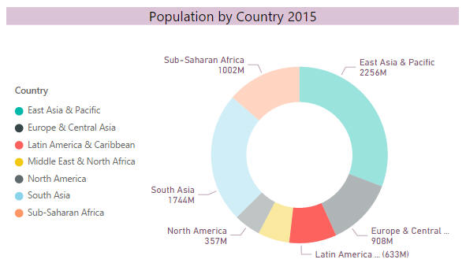

*Here we've moved the legend to the left centre, set a title and customised data label settings.*

Now right-click to exclude **South Asia**and **East Asia & Pacific**from your chart (they're too big), and turn it into a tree chart looking similar to this:

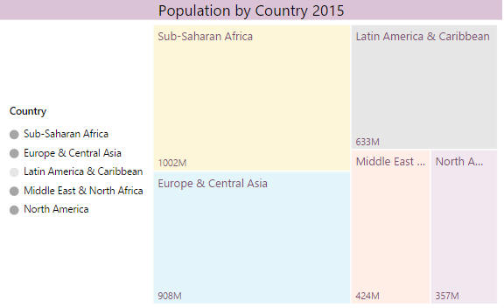

*Here we've made the colours a bit pastellier (is there such a word?).*

Save this file as **Donuts and trees**, then close down this instance of Power BI Desktop.

**2)** For this Exercise use the **Calories** dataset from the given link

Create a pie (or pizza?) chart to compare the average calories for the 3 different types of pizza:

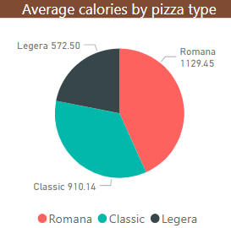

*Add a legend to your pie chart (to appear at the bottom centre) and configure your data labels to show the category and detail value for each slice.*

Add a doughnut (leggera?) chart to show the breakdown of calories by pizza:

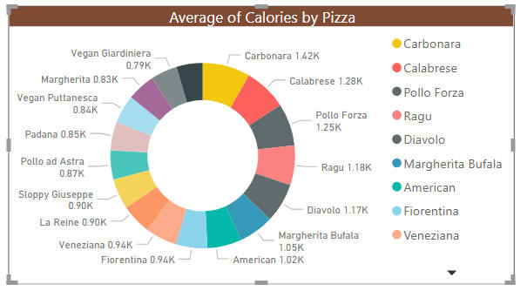

*The chart should show average calories for each pizza.*

*Always remember that you can use the****Format Painter****tool to copy the format from one visual to another.*

Configure your visual interactions so that when you click on a type of pizza in the first chart, it filters the data in the second one.  When you click on the **Leggera** data type in the first chart, this is what the second should show:

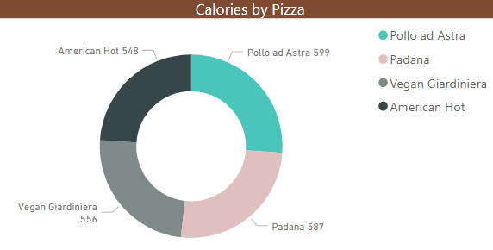

*The button to edit interactions is on the****Format****menu.*

Save your report as **The Hole Truth**, then close it down.

**3)** For this Exercise use the **SkyScrapers** dataset from the given link

To whet your appetite, create a cheeky card to show the number of skyscrapers:

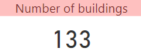

*You'll need to turn the****Category Label****off and the****Title****on to get this effect.*

Create a bar chart comparing the number of buildings for each country:

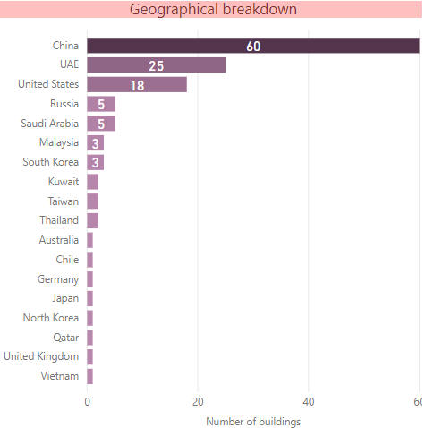

*Your chart should show data labels inside the bars, and have conditional formatting to show countries with more skyscrapers in darker colours.*

Add the **City** column to the chart and turn on drill mode.  When you click on a bar in the chart you should see a count of the number of skyscrapers for each city in the country you've clicked on:

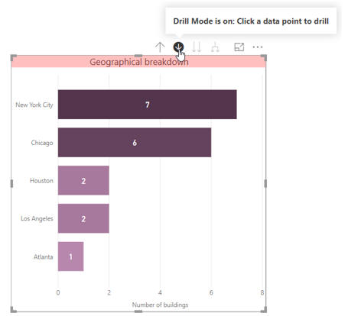

*For example, this is what you should see when you click on the****USA****bar.*

Save your report as **Symbols of what though**, and close it down.

**4)**For this Exercise use the **UK Crime figure 2018** dataset from the given link

Add a gauge to show the number of crimes with a target (invented!) of 4000 and a range from 0 to 5000:

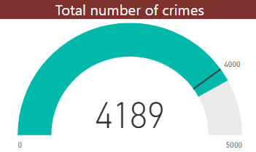

*Switch to the formatting properties of the gauge to set an absolute minimum and maximum value.*

Now add a KPI to show the number of crimes by month:

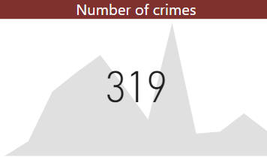

*The figure shown is the number of crimes for the final month in the period - for this visual there doesn't seem to be any obvious way of altering the number shown.*

Finally, add a column chart comparing crime figures by category and quarter:

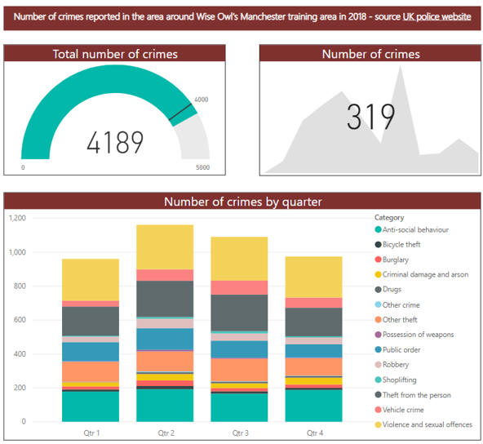

*Do stacked column or bar charts actually reveal anything?*

Save this report as **Reported crime**, and close it down.

**5)**For this Exercise use the **Million-Sellers** dataset from the given link

The aim of this exercise is to create two charts, and get choices you make in one to influence the other - instructions follow, so please read on!

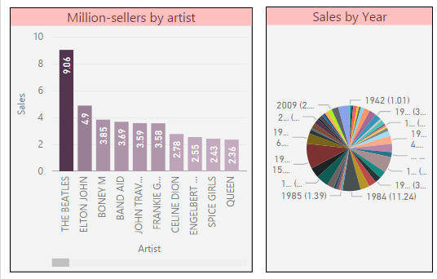

*The two charts we'll (eventually) create.*

 Start by creating the following chart, or as close to it as you can get:

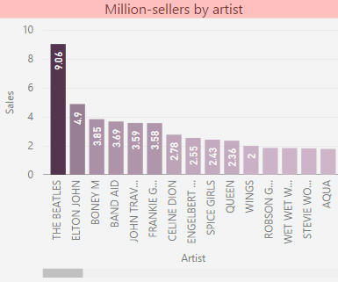

*Colour saturation has been set to colour charts according to the volume of sales, and data labels applied inside each column bar.  The chart is sorted by volume of sales (you could scroll right to see the less successful artists).*

Now create a pie chart which shows the volume of sales by year (it will look messy, because there are too many data points):

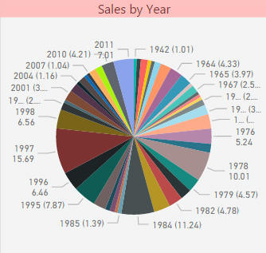

*Things will look better in a moment ...*

*The easiest way to format the second chart is just to paste the format settings from the first.*

Change your interactive visual settings so that when you click on an artist in the column chart, it filters the pie chart:

|  |  |
| --- | --- |
| *The column chart* | *The pie chart* |
| *Column chart* | *Pie chart* |

Save this file as **Linked charts**, then exit this instance of Power BI Desktop.

**6)**For this Exercise use the **Create-a-Creature** database from the SQL Server

Create a new Power BI Desktop file,

From this database load the following tables:

* **tblCentre**
* **tblCentreType**
* **tblPurchase**

Create the following bubble chart!

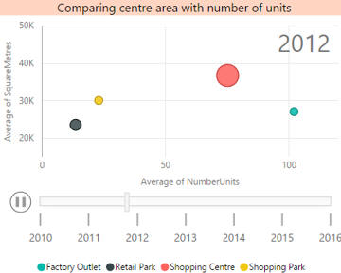

*Here we're in the middle of playing the chart - we've reached 2012. The printed page doesn't do justice to the tackiness of the bubbles shooting around the chart!*

Save this as **Just bubbles**, then close down the Power BI instance.

**7)** The Link folder contains 3 files: two in CSV format and one in Excel.  Create a new Power BI report, and load these 3 files : Director ,Genre and Netfilx titles

Create a tree map visual based on the table of genres:

Tree map

*The trick to getting the rectangles the same size is shown below.*

The field well for the tree map should look like this:

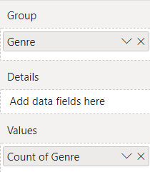

*By adding the Genre field to the Group and Values sections you ensure that each tree map rectangle is the same size.*

**Add a column chart** showing the length of each film, and get this to be filtered when you click on a genre. for example, when you click on the **Sports** genre in the tree map visual it should show the respective films in column chart:

*To keep you busy, you'll need to set conditional formatting and axis titles, and make sure that the sorting is correct.*

Save this report as **Treemendous**, then close it down.

**8)**For this Exercise use the **Completed tests 2018** dataset from the given link

Create a waterfall chart showing for each month the two leading causes of a change in the number of tests taken (with everything else lumped together as **Other**):

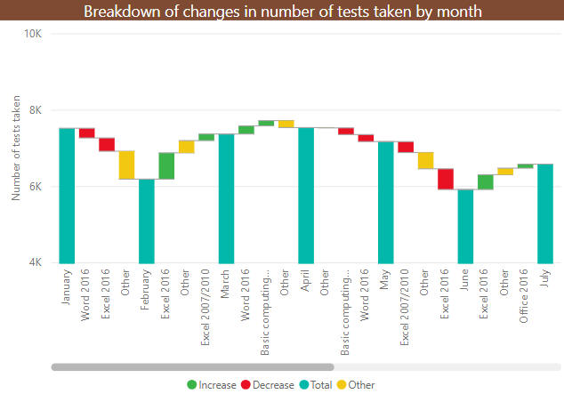

*Unsurprisingly, the yellow****Other****category is often the biggest.*

Save this report as **May the force be with you**, then close it down.